STUDENT REPORT CARD GENERATOR
@CREATIVITY THINK (9483175986/7019689991)

ABSTRACT:
Student Report Card Generator is a web application designed to streamline the process of recording student marks, calculating performance scores, generating report cards, and exporting them in PDF format. Users such as teachers and tutors can input student marks, view dashboards, and download report cards. Administrators manage students and subjects, handle bulk score updates, export multiple reports, and monitor analytics. Built using Django and Django Rest Framework for backend services and React with pdfkit and Recharts for frontend visualization, this system enhances academic performance tracking, simplifies report generation, and provides comprehensive analytics for educational institutions..

INTRODUCTION OF THE PROJECT:
Academic performance monitoring requires systematic entry of marks, performance tracking, and generation of student report cards. Student Report Card Generator provides a user-friendly interface for teachers to enter marks, calculate scores, and generate PDF reports. Administrators can add students and subjects, manage score records, perform bulk report exports, and review dashboard analytics. The backend, powered by Django and Django Rest Framework, handles data storage, authentication, and calculations, while React, pdfkit, and Recharts provide dynamic dashboards, charts, and report export functionality. This platform simplifies report card generation and ensures accuracy in academic evaluation..

PROJECT OBJECTIVES:

• Provide an easy-to-use interface for entering student marks
• Calculate performance scores and academic metrics automatically
• Generate individual report cards in PDF format
• Enable bulk export of report cards for administrative purposes
• Visualize student performance using dashboards and charts
• Maintain a structured database of students and subjects
• Reduce errors in manual report card generation

PROBLEM OF THE STATEMENT:
Manual report card generation is time-consuming, error-prone, and difficult to manage for large batches of students. Teachers spend significant time calculating scores and formatting reports, while administrators face challenges in aggregating data for analytics. Student Report Card Generator addresses these challenges by automating marks entry, performance calculations, PDF report generation, bulk export, and dashboard analytics. The system ensures accuracy, efficiency, and consistency in student performance reporting, while providing administrators with actionable insights..

MOTIVATION OF THE PROJECT:
• Streamline the report card generation process for schools and tutors
• Reduce manual errors in calculating scores and formatting reports
• Enable easy export of individual or bulk report cards
• Provide visual dashboards for performance tracking
• Facilitate data-driven academic analysis for administrators

BLOCK DAIGRAM OF PROJECT:

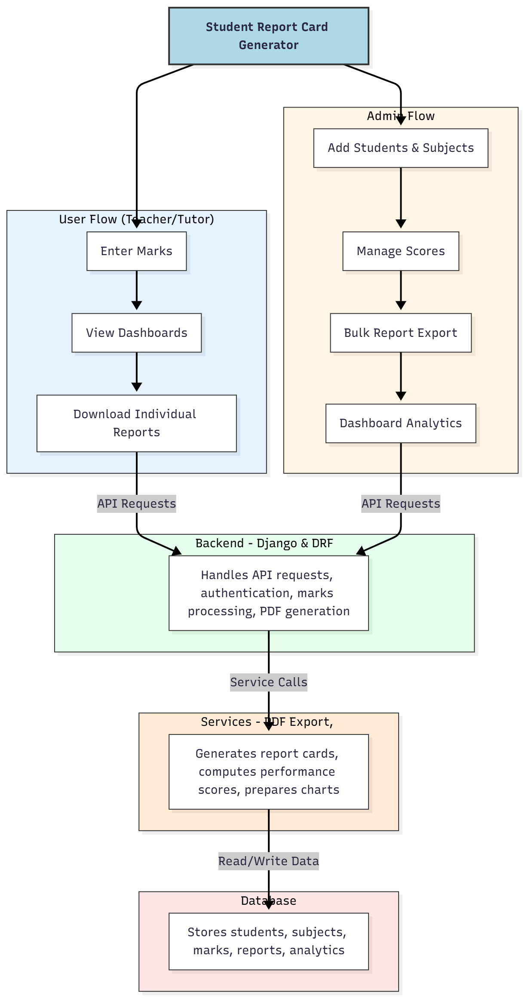

WORKING OF THE PROJECT:
Teachers and tutors enter student marks, view performance dashboards, and download individual report cards in PDF format. The backend handles API requests, authentication, score processing, and PDF generation. Services manage the generation of report cards, performance computation, and dashboard analytics. Administrators add and manage students and subjects, update scores, perform bulk report exports, and monitor overall analytics. This system ensures efficient, accurate, and timely generation of academic reports for students, while providing actionable insights for administrators..

SOFTWARE REQUIREMENT:
- Backend:
  - Python 3.x
  - Django
  - Django REST Framework
  - SQLite/PostgreSQL
- Frontend:
  - Node.js and npm
  - React.js
  - Axios
- Development Tools:
  - Visual Studio Code
  - Postman (for testing APIs)
  - Git/GitHub (for version control)
- Server/Deployment (Optional):
  - Gunicorn, Nginx, or Heroku/AWS for hosting

ADVANTAGES OF THE PROJECT:

• Automates student marks entry and report generation
• Supports PDF export for individual and bulk report cards
• Provides dashboards and charts for visual performance analysis
• Centralized student and subject management
• Reduces manual errors in calculations and formatting
• Efficient handling of large batches of students
• Enhances administrative workflow and reporting
• Supports academic decision-making through analytics

APPLICATIONS OF THE PROJECT:
• Schools for academic performance tracking
• Tutors managing multiple students’ progress
• Learning centers for report card generation
• Academic dashboards for administrators
• PDF report card distribution
• Bulk report export for parent communication
• Visual analysis of student performance trends
• Data-driven insights for educational planning

REFERENCES:

- Django REST Framework Documentation — Django Software Foundation. Django Documentation. Available: https://docs.djangoproject.com/
- Django REST Framework. DRF Documentation. Available: https://www.django-rest-framework.org/
- React. React Official Documentation. Available: https://reactjs.org/docs/getting-started.html
- Redux. Redux Documentation. Available: https://redux.js.org/introduction/getting-started
- PostgreSQL Global Development Group. PostgreSQL Documentation. Available: https://www.postgresql.org/docs/
- MySQL. MySQL Reference Manual. Available: https://dev.mysql.com/doc/
- Git. Git Documentation. Available: https://git-scm.com/doc
- Node.js. Node.js Documentation. Available: https://nodejs.org/en/docs/
- Axios. Axios Documentation. Available: https://axios-http.com/docs/intro
- Socket.io Documentation – https://socket.io/docs/

